PIZZA SALES SQL QUERIES
A. KPI’s
1. Total Revenue:
select round(sum(total_price),2) as 'Total Revenue'
from pizza_sales;

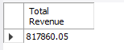
2. Average Order Value
select round(round(sum(total_price))/count(distinct order_id),2) as 'Average Order Value'
from pizza_sales;

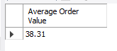
3. Total Pizzas Sold
select sum(quantity) as 'Total pizza sold'
from pizza_sales;

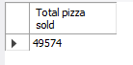
4. Total Orders
select count(distinct order_id) as 'Total order'
from pizza_sales;

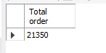

5. Average Pizzas Per Order
select round(sum(quantity)/count(distinct order_id)) as 'Average pizza per order' from pizza_sales;

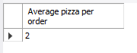

B. Daily Trend for Total Orders
select dayname(order_date) as Order_Day, count(distinct order_id) as Total_Orders
from pizza_sales
group by Order_Day
order by Total_Orders Desc;

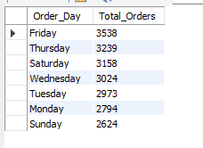

C. Hourly Trend for Orders
select hour(order_time) as 'Order hour', count(order_id) as 'Total Orders'
from pizza_sales
group by hour(order_time)
order by hour(order_time);
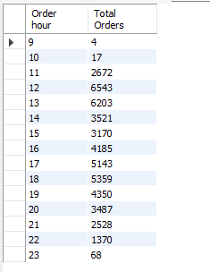

D. Percentage of Sales by Pizza Category
select pizza_category as 'Pizza category',
round(sum(total_price)) as 'Total Sales',
round(sum(total_price)*100/(select sum(total_price) from pizza_sales),2) as Percentage
from pizza_sales
group by pizza_category
order by Percentage desc;

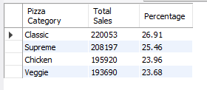
E. Percentage of Sales by Pizza Size
select pizza_size as 'Pizza size',
round(sum(total_price)) as 'Total Sales',
round(sum(total_price)*100/(select sum(total_price) from pizza_sales),2) as Percentage
from pizza_sales
group by pizza_size
order by Percentage desc;
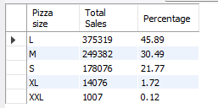
F. Total Pizzas Sold by Pizza Category
select pizza_category, sum(quantity) as 'Total Pizza Sold'
from pizza_sales
group by pizza_category
order by sum(quantity) desc;

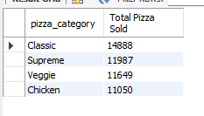
G. Top 5 Best Sellers by Total Pizzas Sold
select pizza_name, sum(quantity) as 'Total Pizza Sold'
from pizza_sales
group by pizza_name
order by sum(quantity) desc
limit 5;

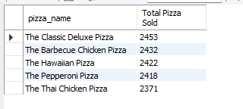

H. Bottom 5 Best Sellers by Total Pizzas Sold
select pizza_name, sum(quantity) as 'Total Pizza Sold'
from pizza_sales
group by pizza_name
order by sum(quantity)
limit 5;

